**Assignment (1)**

1. 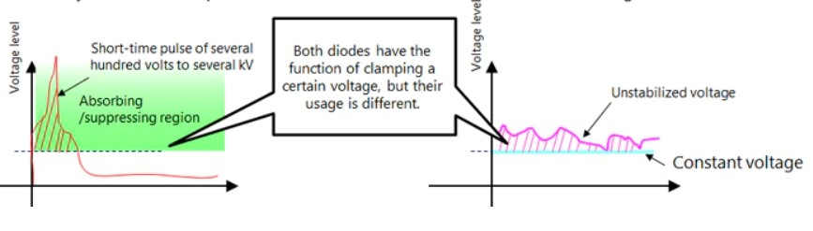

|  |  |
| --- | --- |
| **TVS** | **Zener Diodes** |
| * It is diode engineered to protect electronic circuits from induced voltage spikes on wires. * It is used to absorb and control electrically and short-time pulses (surges). | * Zener diodes are engineered to regulate voltage operating in the breakdown region. * Zener diodes clamp unstabilized voltage performing a constant voltage drop on the protected circuit. |

|  |  |
| --- | --- |
| **Varistors** | **TVS** |
| * Varistors are resistors that have a variable value according to the applied voltage on it. * Their resistance decrease when the voltage on them increases. * Varistors can be used when slow response is needed. * Varistors are cheap, thus can be used as a sacrificial component. * Varistors has high capacitor and high power ratings. * Used in AC power supply to make the fuse burnt not the circuit | * TVS is a diode that is connected to a circuit in a reverse biased technique to prevent any electrical surges from destroying the circuit. * TVS are used when high response are needed. * TVS is expensive, not the best scenario to sacrifice it while using it in the circuit. * Low capacitor in its model (advantage) and low power ratings. * Used in applications to protect it from spikes due to static friction. (high frequency). |

1. **Power supply oring:**

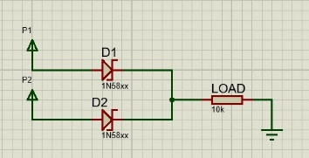There are a number of situations where power must be combined between sources to power the load. High-power systems like blade servers may have multiple power sources for flexibility. Schottky diodes are used to cancel the issues of power combination such as failures, short, hot-plug, or removal of one device.

1. **Reverse polarity protection:**

It is a circuit used to ensure that the device is not damaged even when the power supply polarity is reversed. This protection is preferred to be made using Schottky diodes due to its low voltage drop on it as well as it is suited for low voltage and current circuits demands. It is done by connecting it in series with the protected circuit.

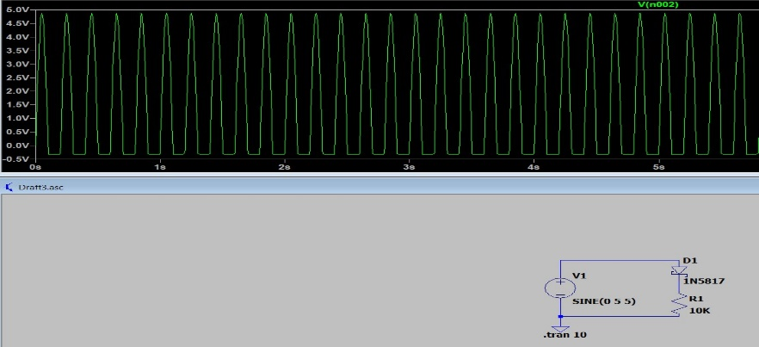

1. **Fly wheel:**

Using Schottky diode, the circuit which is consisted of R-L load is protected from voltage spikes generated according to Lenz rule when turning off the power switch on the inductor.

Note: cannot find switch in LTspice.

1. **Rectification:**

There are two types of rectification: full wave and half wave rectification.

